* **✅ Real API ingestion project**
* ✅ Let's walk **step-by-step** through how to build a **real API ingestion project** in Azure — where we ingest data from an API (like https://fakestoreapi.com/products) into a **SQL Database**, and optionally to **Data Lake / Power BI**.
* **✅ 1️. Business Requirement (What’s the goal?)**
* 🚀 “Pull product data from a live API and store it into an Azure SQL Database for analytics and reporting.”
* **✅ 2️. High-Level Architecture:**
* 
* **✅ 3️. Tools/Services Needed**

| **Tool** | **Use** |
| --- | --- |
| 🔧 Azure Data Factory | Orchestrate and copy data |
| 🌐 HTTP Connector | Connect to API |
| 📊 Azure SQL Database | Store structured product data |
| 🔐 Linked Services | Secure connections |
| 📁 Datasets | Define source & sink metadata |

✅ 4️. Step-by-Step Implementation

🔹 Step 1: Understand the API

* Endpoint: https://fakestoreapi.com/products
* Returns JSON data with product fields like: id, title, price, rating → {rate, count }
* Structure = **JSON Array**

**🔹 Step 2: Create Azure SQL Table (Target)**

**SQL:**

CREATE TABLE Products (

id INT,

title NVARCHAR(255),

price FLOAT,

description NVARCHAR(MAX),

category NVARCHAR(100),

image NVARCHAR(500),

rating_rate FLOAT,

rating_count INT

);

🔹 Step 3: Create ADF Pipeline

1. Linked Services
   * Create HTTP linked service (to fakestoreapi)
   * Create SQL DB linked service (your Azure SQL)
2. Datasets
   * Source: HTTP dataset (JSON format)
   * Sink: SQL Table dataset
3. Copy Activity
   * Map rating.rate ➝ rating_rate, rating.count ➝ rating_count
   * Use Import Schema → From sample file or JSON preview
4. I configured triggered- That trigger will run every 2 minutes.

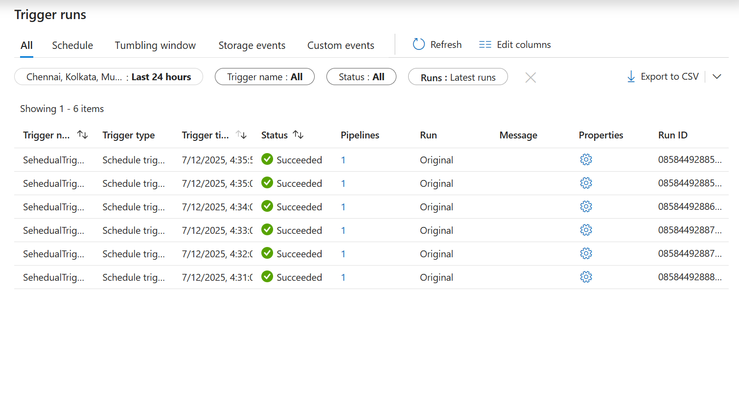

1. Finally Copy activity and Trigger run successfully and data copy from API to SQL DB.

